**LOVELY PROFESSIONAL UNIVERSITY**

**Submitted to:- Ms.Ishatpreet Kaur**

**TOPIC:- RESTAURANT**

**INTERNET PROGRAMMING LANGUAGE**

**CSE326**

**SUBMITTED BY:**

**Group member 1 Dhaireya Abhilashi(RK19RDA28)**

**Group member 2** Ashutosh Pandey**(RK19RDA29)**

**Group member 3** Jeeva Natrajan **(RK19RDA30)**

INTRODUCTION TO OUR IDEAS

**Standard elements**

**which will be present in every page of the website**

**OUR WEBPAGES**

**HOME PAGE**

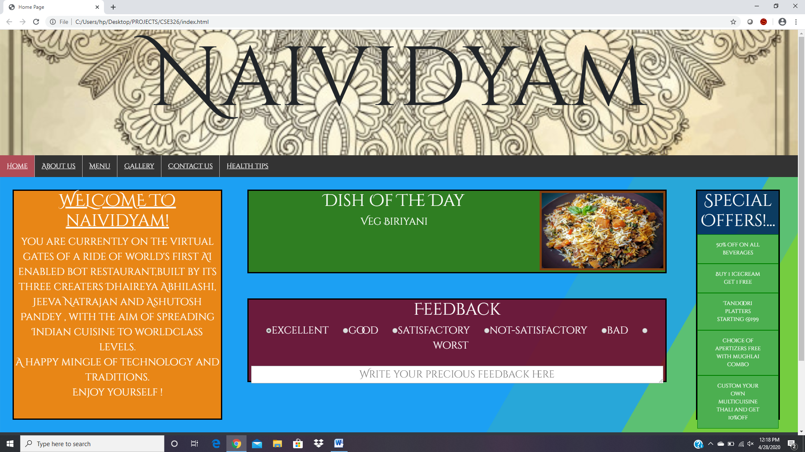Screenshot of home page

**ABOUT US PAGE**

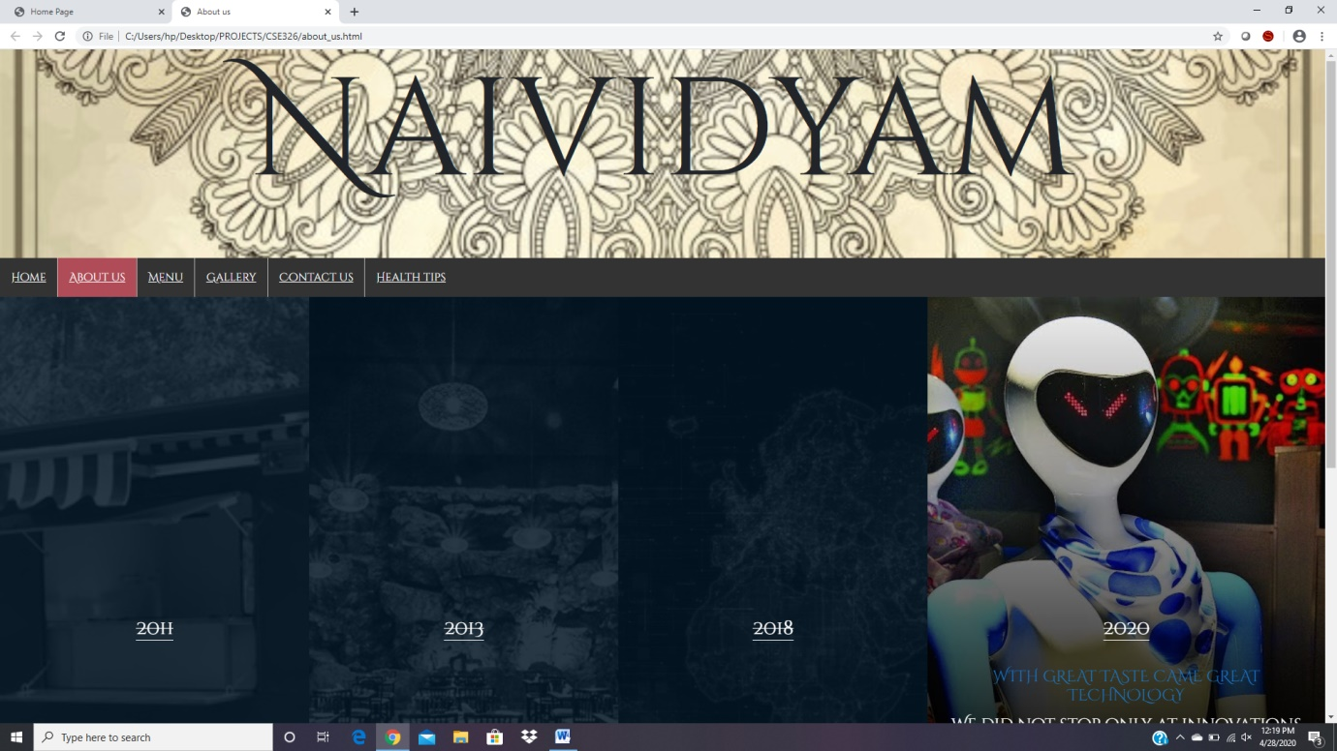Screenshot of about us page

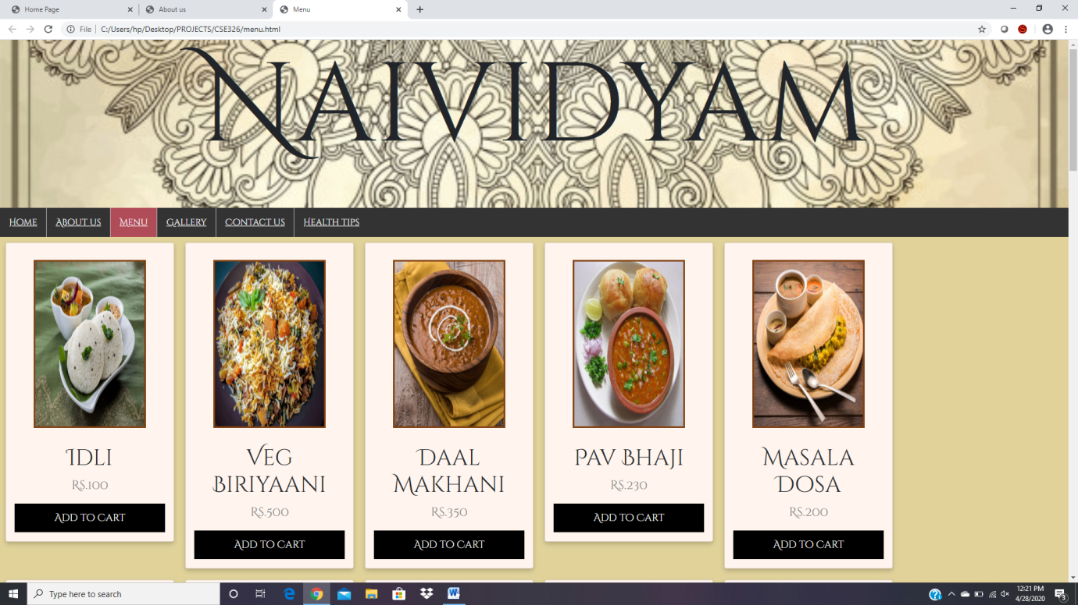Screenshot of menu page

**MENU PAGE**

**GALLERY PAGE**

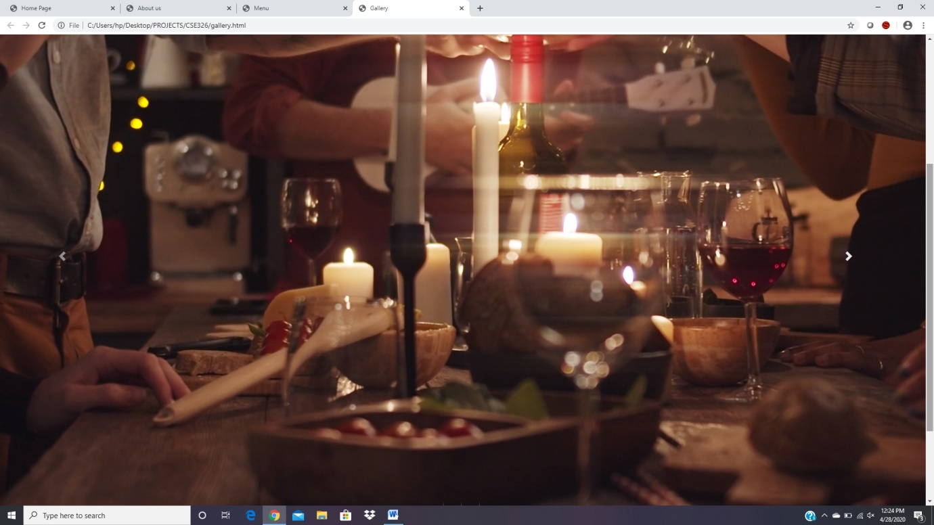**Screenshot of gallery page**

**CONTACT US PAGE**

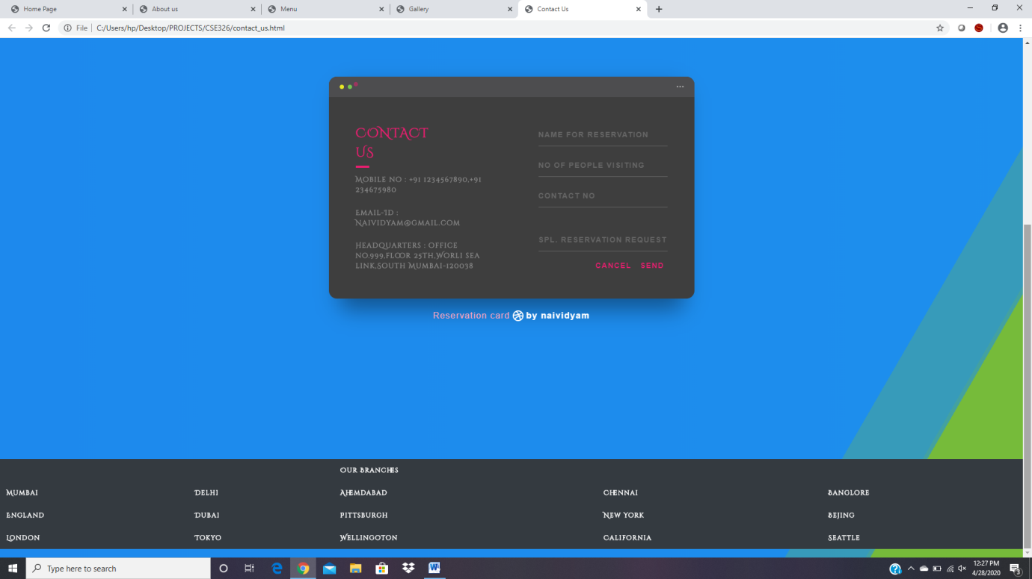Screenshot of contact us page

**HEALTH TIPS PAGE**

Screenshot of health-tips page

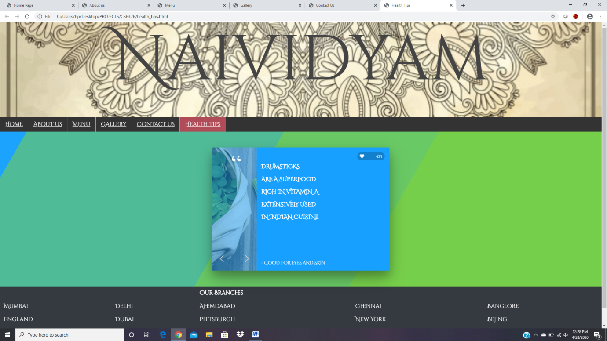

According to the above goals that we had set we have received all the outputs correctly and have also fulfilled all the goals that we wanted to achieve in our website.

Following icon will take you to a Gantt chart which will help explain the contribution of each team member towards this project.

This Gantt chart is present as a separate excel sheet in a directory(folder) named explanation of project in this repository.

**Please click me to move to the Gantt chart!**